E-COMMERCE SALES ANALYSIS USING MICROSOFT SQL SERVER

A Comprehensive Data Analysis Project Using SQL

Project Report

Submitted By

Sumit Kohli

Aspiring Data Analyst

Technologies Used
- Microsoft SQL Server
- SQL Server Management Studio (SSMS)
- T-SQL
- Microsoft Excel (Data Preparation)
- GitHub

Key Skills Demonstrated
- Database Design
- Data Cleaning
- Data Analysis
- SQL Joins
- Aggregate Functions
- Window Functions
- Common Table Expressions (CTEs)
- Ranking Functions
- Subqueries
- Views
- Stored Procedures
- Business Insights
- Performance Optimization

Project Duration
July 2026

Prepared By
Sumit Kohli
Data Analyst Portfolio Project
GitHub Portfolio
LinkedIn Portfolio

Version 1.0
July 2026
There are our Problem Statement
Q1 Which products sell the highest quantity?
Q2 Which categories contribute the most revenue?
Q3 Which brands generate the highest sales?
Q4 Which suppliers contribute the highest sales?
Q5 Which warehouse processes the highest sales?
Q6 Which cities generate the highest revenue?
Q7 Which customers contribute the most revenue?
Q8 Which products have never been sold?
Q9 Which products are out of stock?
Q10 Which products are below the reorder level ?
Q11 Which warehouse has the highest stock?
Q12 Which warehouse has the lowest stock?
Q13 Which products have excess inventory?
Q14 Which categories have the highest inventory value ?
Q15 What is the total inventory value?
Q16 Which supplier's products remain unsold?
Q17 Which warehouse needs replenishment first?
Q18 Which courier delivers the fastest?
Q19 Which courier delivers the slowest?
Q20 Average delivery time by courier.
Q21 Which warehouse has the most delayed deliveries?
Q22 What percentage of orders are delivered on time?
Q23 Which shipping routes experience delays?
Q24 Which city has the highest delivery delays?
Q25 Average shipping cost by warehouse?
Q26 Which courier has the highest return rate?
Q27 Which warehouse has the highest shipping cost?
Q28 Which payment method is most popular?
Q29 What is Payment success rate ?
Q30 What is Payment failure rate ?
Q31 What is Total discounts given ?
Q32 What is Total shipping charges collected ?
Q33 What is Total tax collected ?
Q34 Net revenue after discounts.?
Q35 What is Revenue by payment method.?
Q36 What is Refund amount by month ?
Q37 Who are our top 20 customers?
Q38 Which customers haven't ordered in the last 6 months?
Q39 Repeat VS new Customer ?
Q40 Customer lifetime value (CLV). ?
Q41 What is Average orders per customer.?
Q42 Which city has the most loyal customers?
Q43 Which customers frequently return products?
Q44 Which age group spends the most?
Q45 Which gender spends more?
Q46 Which products are returned the most?
Q47 Which category has the highest return rate?
Q48 Which supplier has the highest return rate?
Q49 Which brand has the highest return rate?
Q50 What is Most common return reason.?
Q51 What is Return rate by warehouse ?
Q52 What is Return rate by courier.?
Q53 Which category has the fastest growth?
Q54 Which products should be promoted?
Q55 Which payment method is preferred by premium customers?
Q56 Which city should receive more marketing budget?
Q57 Which categories have declining sales?
Q58 Which brands need promotions?
Q59 Which products generate the highest profit?
Q60 Which products have declining sales?
Q61 Which categories have the highest ASP?

Now we are Going to Solve Our Problem Statement
As Below

Q1 Which products sell the highest quantity?
Ans :
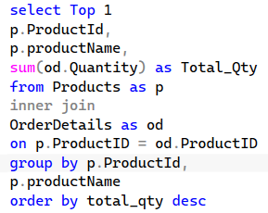
Output:
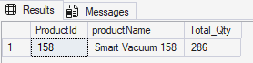
Q2 Which categories contribute the most revenue?
Ans :
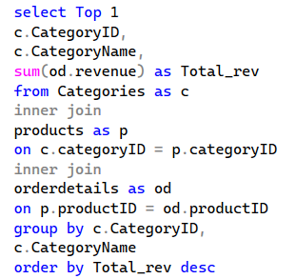
Output:
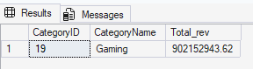

Q3 Which brands generate the highest sales?
Ans :
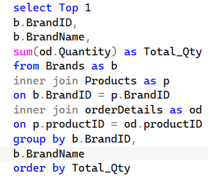
Output :
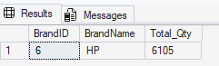
Q4 Which suppliers contribute the highest sales?
Ans :
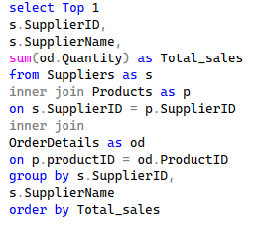
Output :
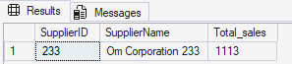

Q5 Which warehouse processes the highest sales?
Ans :
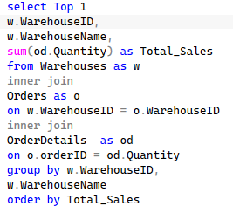
Output :
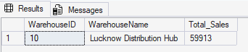
Q6 Which cities generate the highest revenue?
Ans :
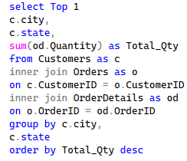
Output :
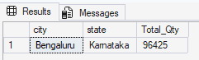

Q7 Which customers contribute the most revenue?
Ans :
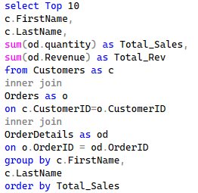
Output :
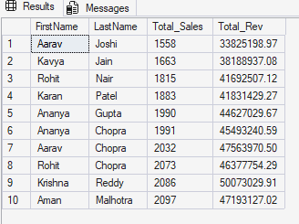
Q8 Which products have never been sold?
Ans :
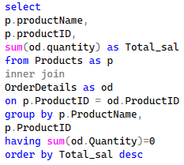
Output :
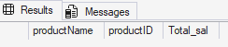
Q10 Which products are below the reorder level ?
Ans :
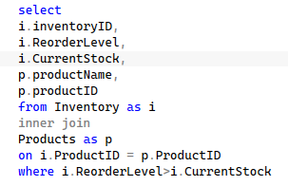
Output :
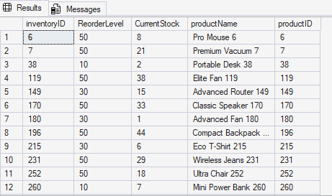
Q11 Which warehouse has the highest stock?
Ans :
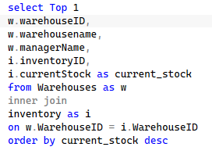
Output :
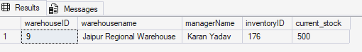
Q12 Which warehouse has the lowest stock?
Ans :
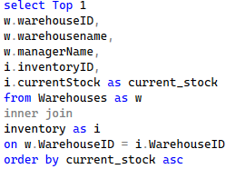
Output :
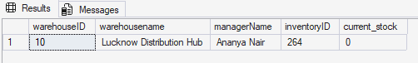
Q13 Which products have excess inventory?
Ans :
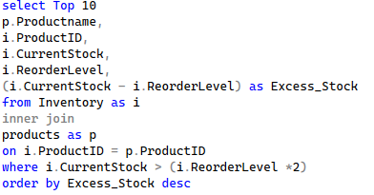
Output:
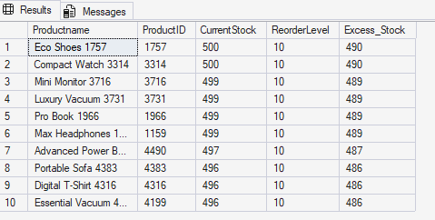
Q14 Which categories have the highest inventory value ?
Ans :
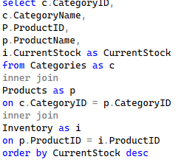
Output:
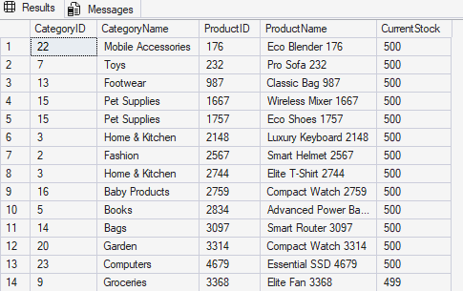

Q15 What is the total inventory value?
Ans :
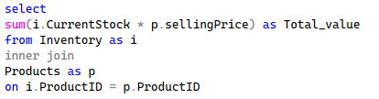
Output :
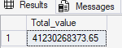
Q16 Which supplier's products remain unsold?
Ans :
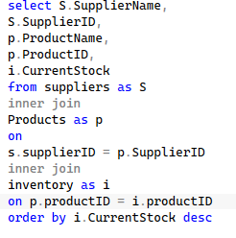
Output :
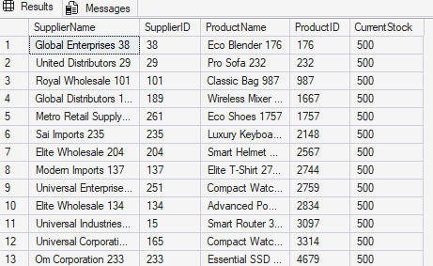
Q17 Which warehouse needs replenishment first?
Ans :
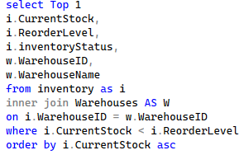
Output :
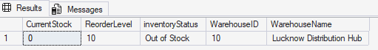
Q18 Which courier delivers the fastest?
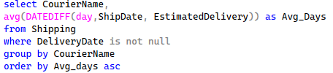
Output :
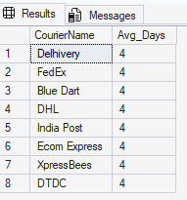
Q19 Which courier delivers the slowest?
Ans :
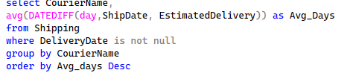
Output :
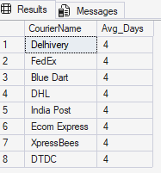
Q20 Average delivery time by courier.
Ans :
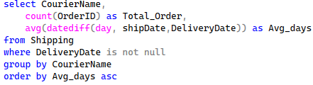
Output :
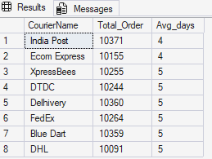
Q21 Which warehouse has the most delayed deliveries?
Ans :
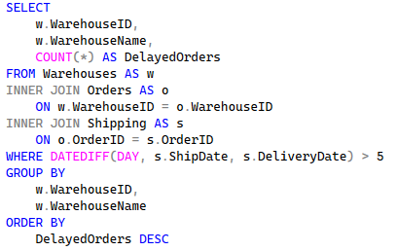
Output :
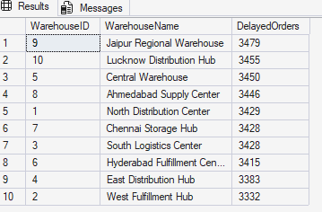
Q22 What percentage of orders are delivered on time?
Ans :
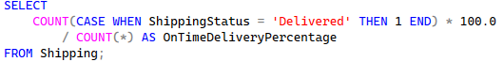
Output :
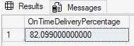
Q23 Which shipping routes experience delays?
Ans :
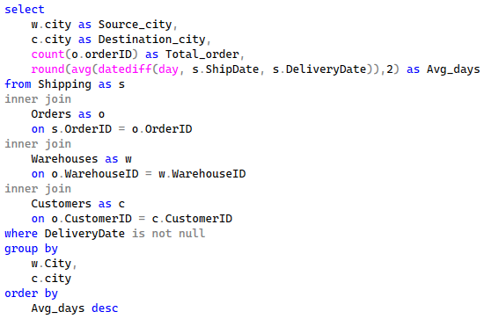
Output :
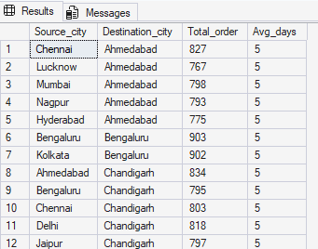
Q24 Which city has the highest delivery delays?
Ans :
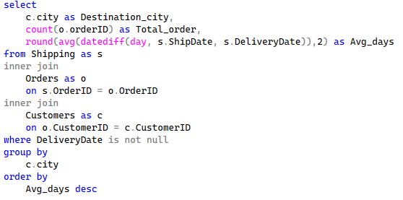
Output:
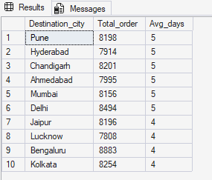
Q25 Average shipping cost by warehouse?
Ans :
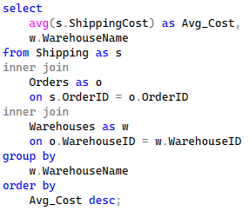
Output:

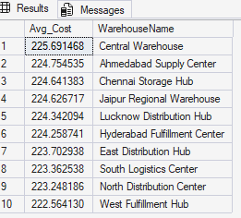
Q26 Which courier has the highest return rate?
Ans :
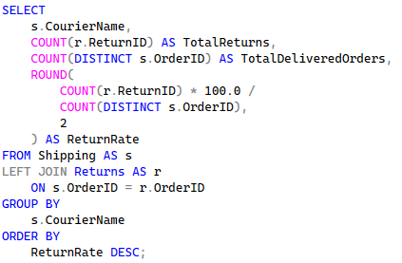
Output :
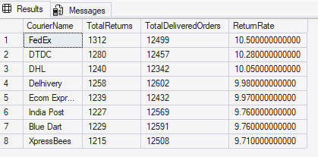
Q27 Which warehouse has the highest shipping cost?
Ans :

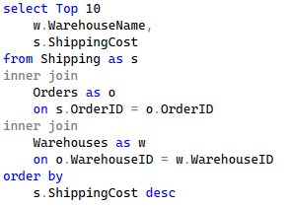
Output :
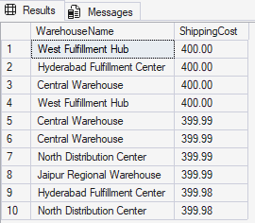
Q28 Which payment method is most popular?
Ans :
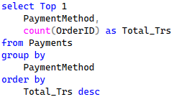
Output :
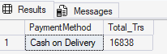
Q29 What is Payment success rate ?
Ans :

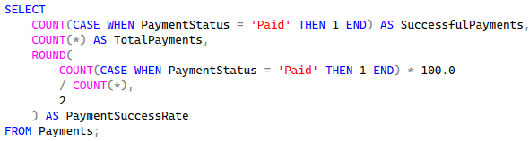
Output :
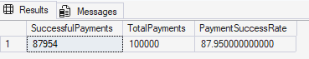
Q30 What is payment Failure rate ?
Ans :
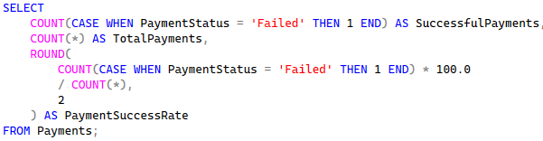
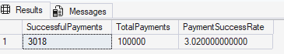
Q31 What is Total discounts given ?
Ans :
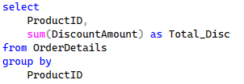
Output :
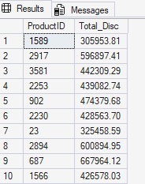
Q32 What is Total shipping charges collected ?
Ans :
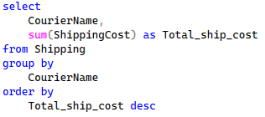
Output :
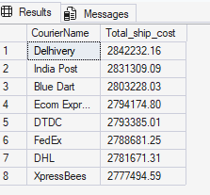
Q33 What is Total tax collected ?
Ans :
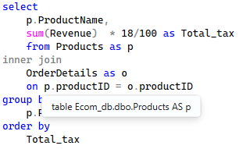
Output :
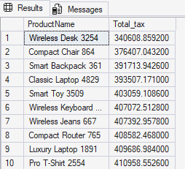
Q34 Net revenue after discounts.?
Ans :
Output :
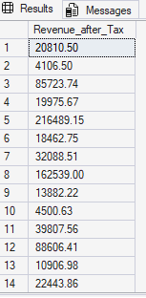
Q35 What is Revenue by payment method.?
Ans : 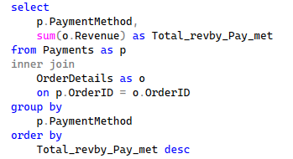
Output :
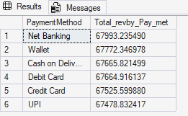
Q36 What is Refund amount by month ?
Ans :
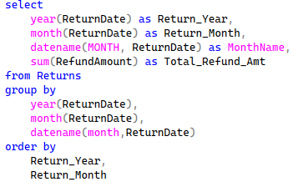
Output :
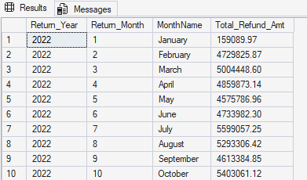
Q37 Who are our top 20 customers?
Ans :
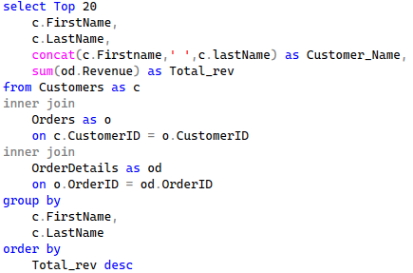
Output :
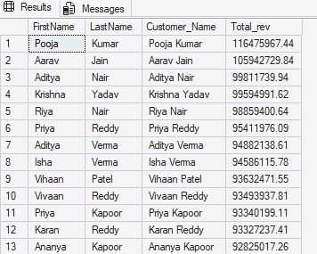
Q38 Which customers haven't ordered in the last 6 months?
Ans : 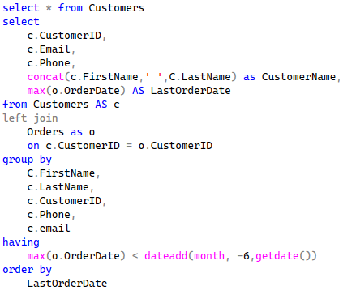
Output :
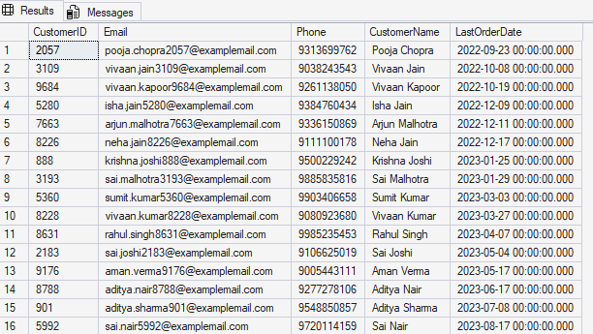
Q39 Repeat VS new Customer ?
Ans :
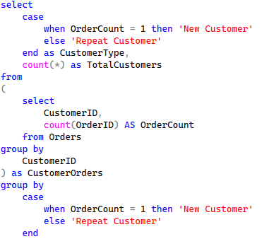
Output :
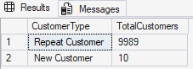

Q40 Customer lifetime value (CLV). ?
Ans :
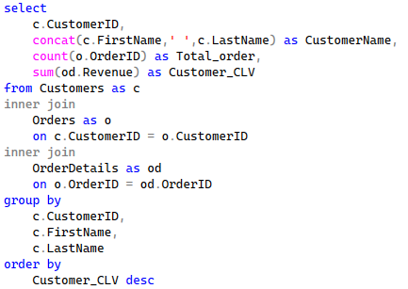
Output :
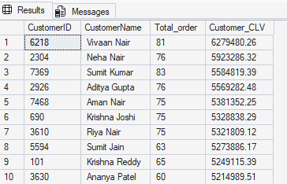
Q41 What is Average orders per customer.?
Ans :
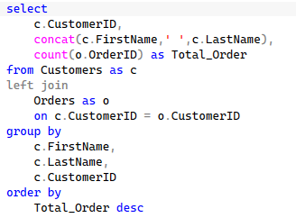
Output :
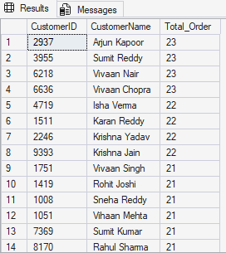
Q42 Which city has the most loyal customers?
Ans :
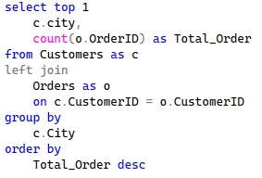
Output :
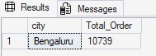
Q43 Which customers frequently return products?
Ans :
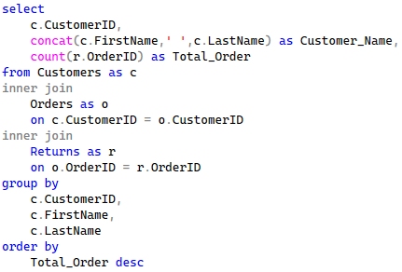
Output :
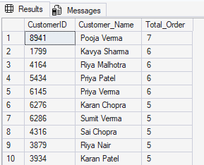
Q44 Which age group spends the most?
Ans : 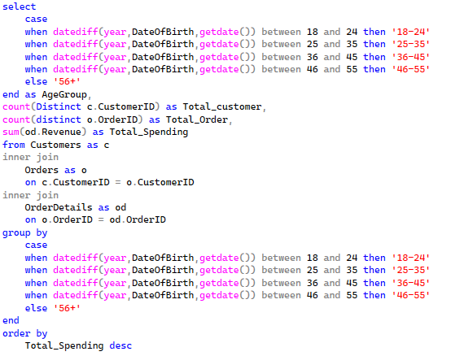

Output :
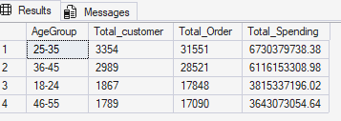
Q45 Which gender spends more?
Ans :
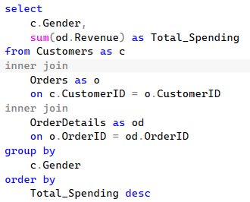
Output :
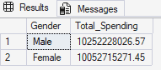
Q46 Which products are returned the most?
Ans :
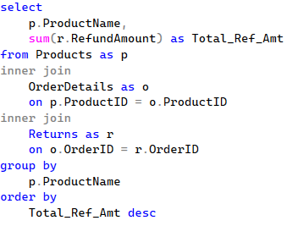
Output :
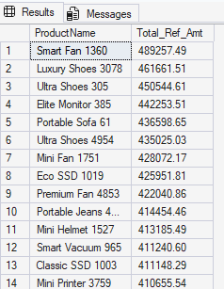
Q47 Which category has the highest return rate?
Ans :
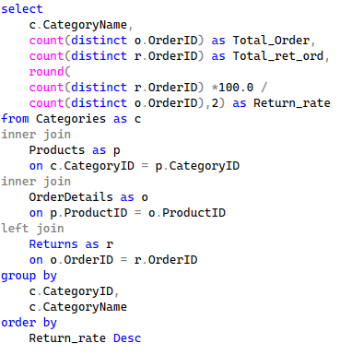
Output :
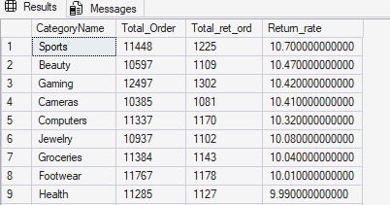
Q48 Which supplier has the highest return rate?
Ans :
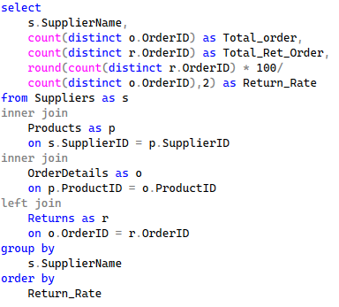
Output :
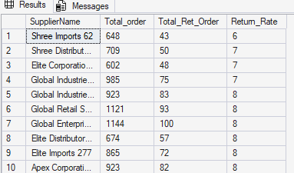

Q49 Which brand has the highest return rate?
Ans :
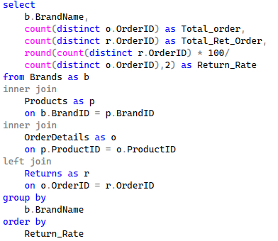
Output :
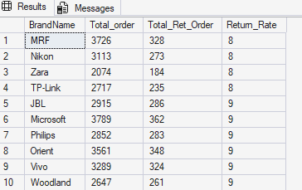
Q50 What is Most common return reason.?
Ans :
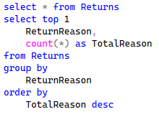
Output :
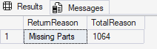
Q51 What is Return rate by warehouse ?
Ans :
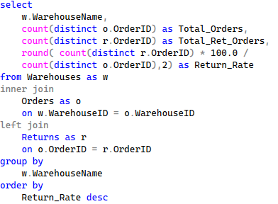
Output:
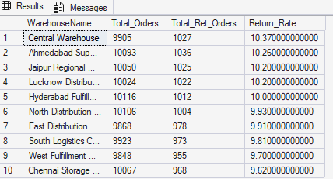
Q52 What is Return rate by courier.?
Ans : 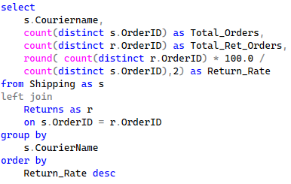
Output :
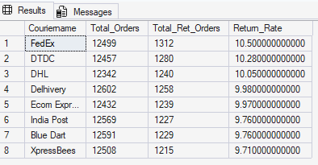
Q53 Which category has the fastest growth?
Ans :
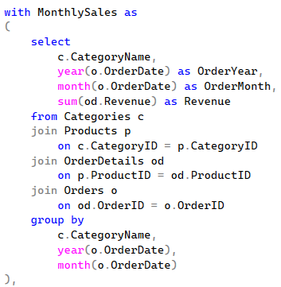
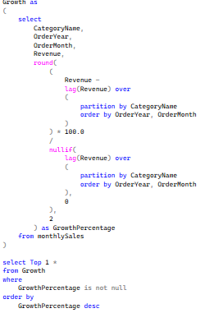
Output :
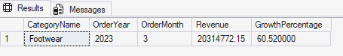
Q54 Which products should be promoted?
Ans :
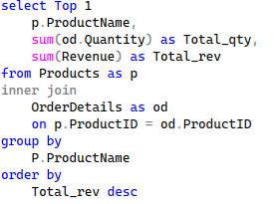
Output:
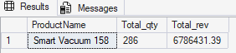
Q55 Which payment method is preferred by premium customers?
Ans:
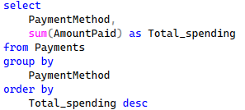
Output :
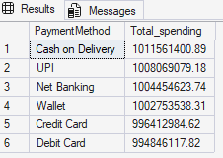
Q56 Which city should receive more marketing budget?
Ans :
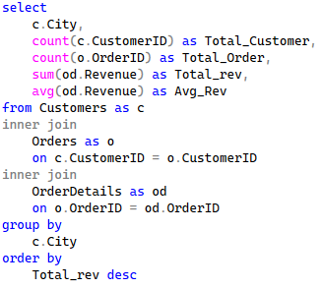
Output :
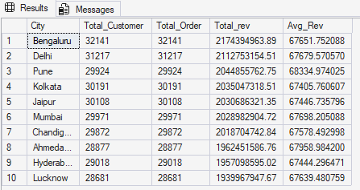
Q57 Which categories have declining sales?
Ans :
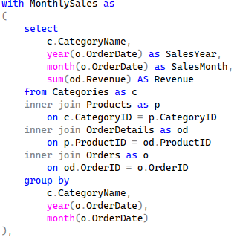
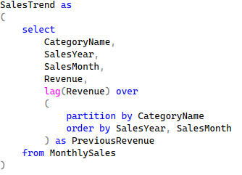
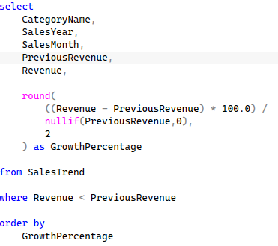
Output :
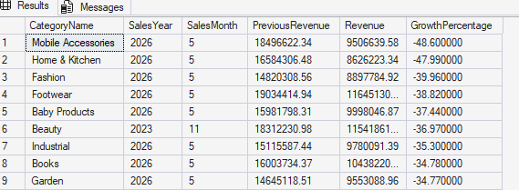
Q58 Which brands need promotions?
Ans :

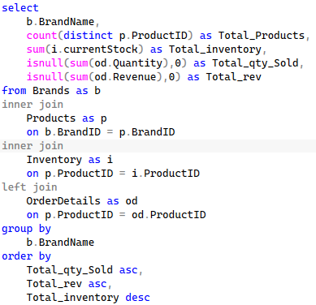
Output :
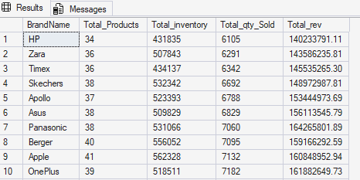
Q59 Which products generate the highest profit?
Ans :
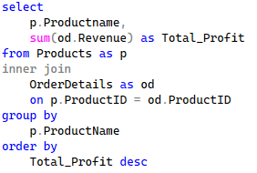
Output :
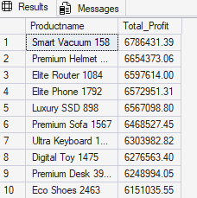
Q60 Which products have declining sales?
Ans :
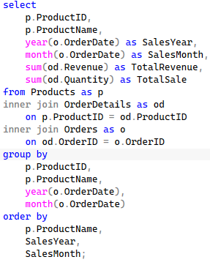
Output :
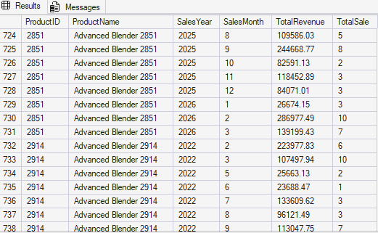
Q61 Which categories have the highest ASP?
Ans :
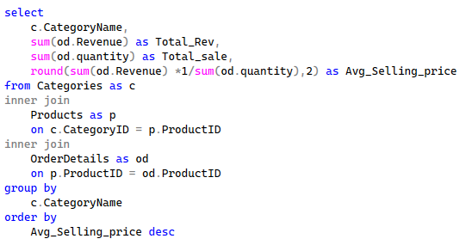
Output :
